

ALUNO (A): ________________________________________ DATA: 29 /06/ 2020.

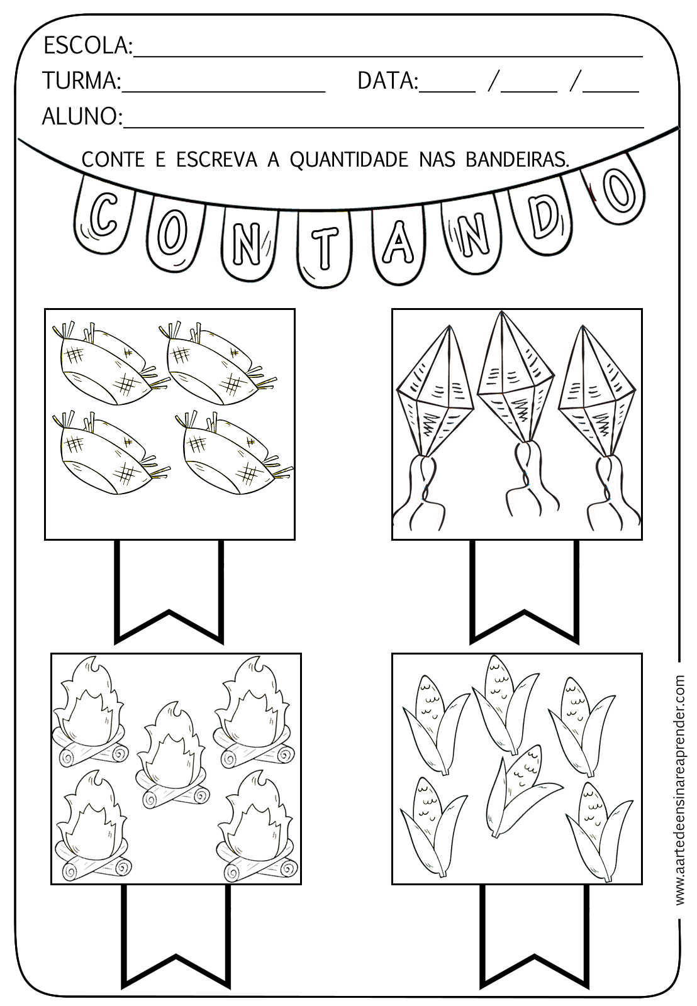PROFESSORA: ____________________________________ MATERNAL II