

ALUNO (A): ________________________________________ DATA: ____ /____/ 2020.

PROFESSORA: _____________________________________ **MATERNAL II**

NO SACO DE PIPOCA PROCURE E PINTE A LETRA DO SEU NOME.

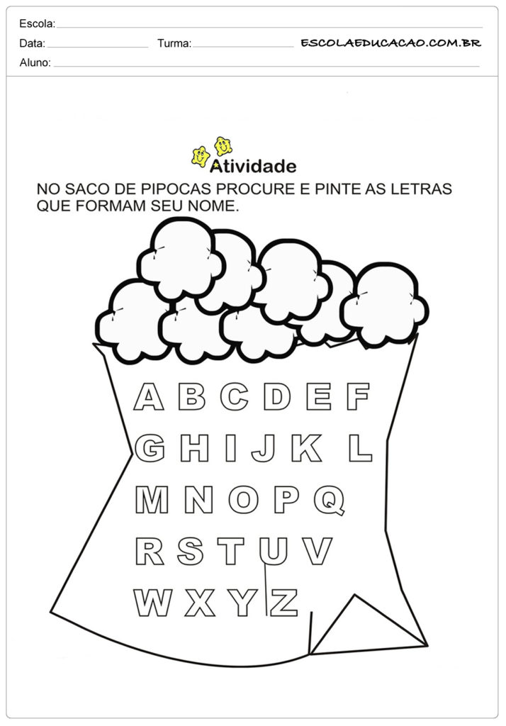



ALUNO (A): ________________________________________ DATA: ____ /____/ 2020.

PROFESSORA: _____________________________________ MATERNAL II

VAMOS LEVAR A MENINA ATE A FOGUEIRA, DEPOIS PINTE O DESENHO.

