

ALUNO (A): ________________________________________ DATA: 18 /08/ 2020.

**PROFESSORA**: ______________________________________________________

**MATERNAL II**

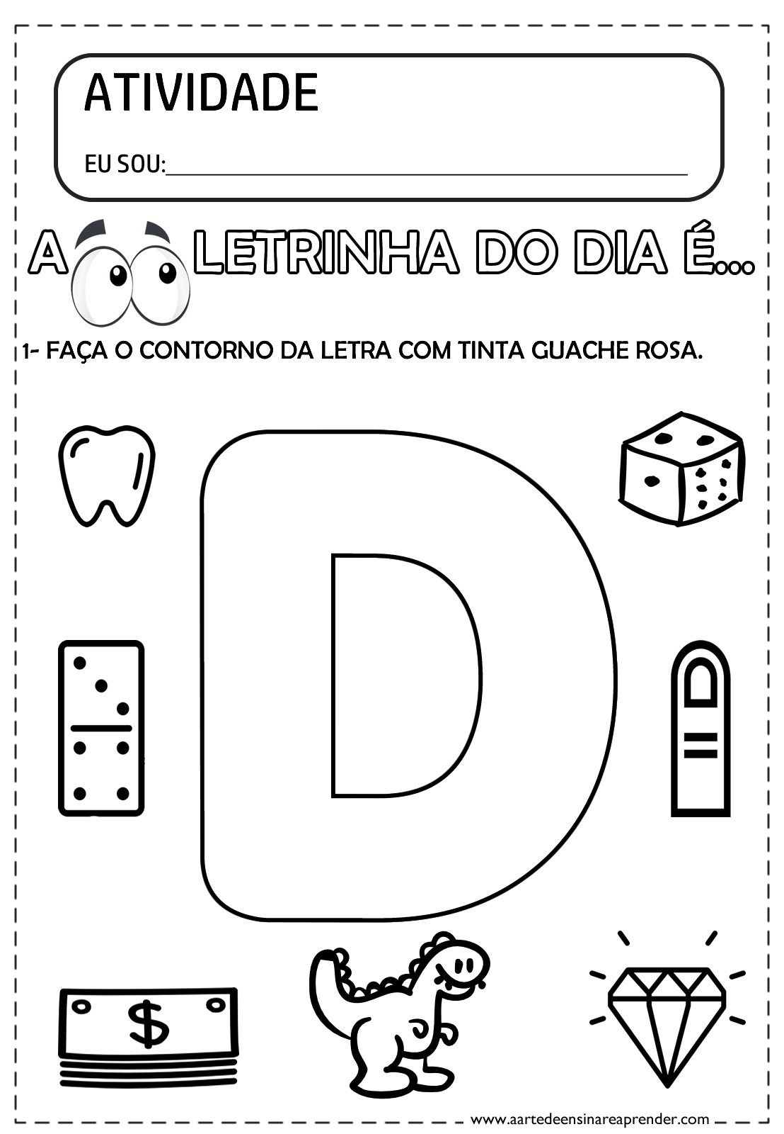

AGORA VAMOS ENCONTRAR E CIRCULAR AS VOGAIS DA PALAVRA:

DINOSSAURO