
ALUNO (A): ________________________________________ DATA: 21 /09/ 2020.
PROFESSORA: _____________________________________ MATERNAL I
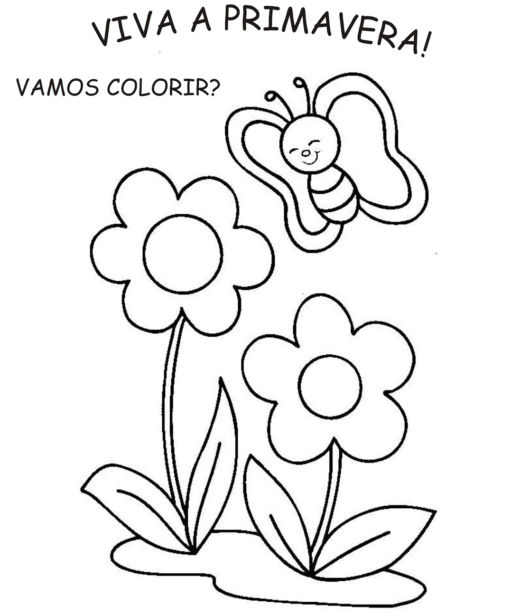
PROJETO AS QUATRO ESTAÕES

