

ALUNO (A): ________________________________________ DATA: 21 /09/ 2020.

PROFESSORA: _____________________________________ MATERNAL I

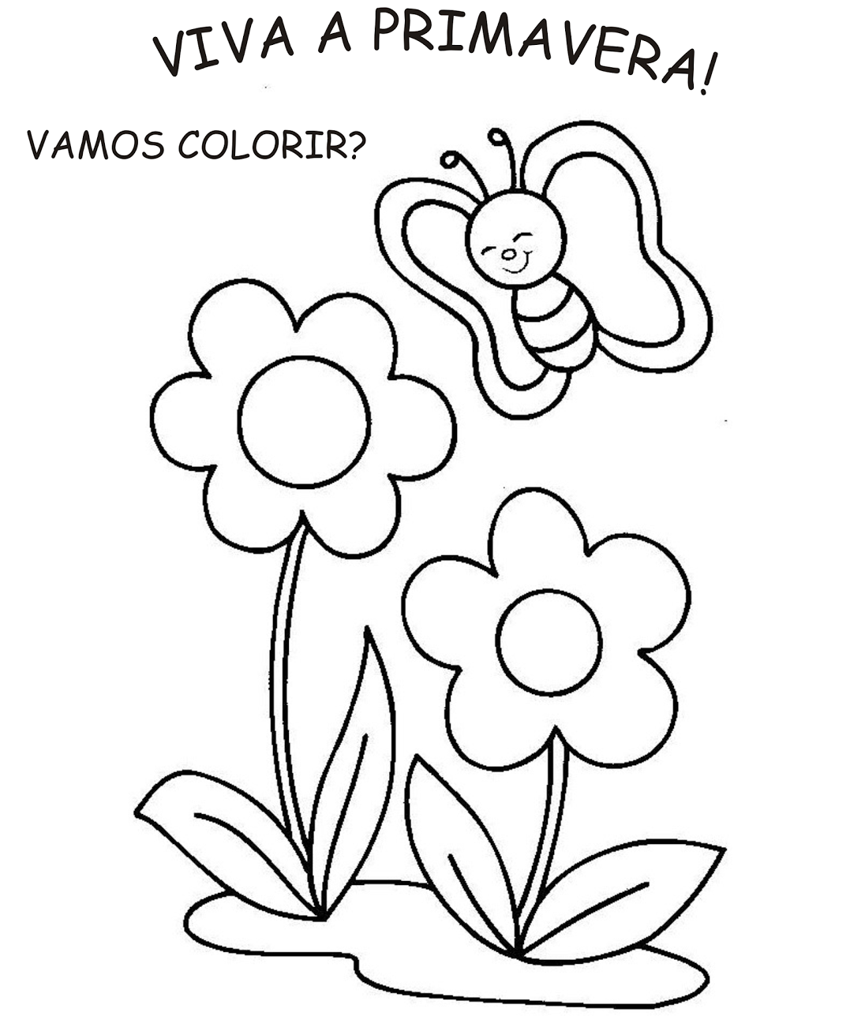**PROJETO AS QUATRO ESTAÇÕES**