

ALUNO (A): ________________________________________ DATA: 09 /09/ 2020.

PROFESSORA: _____________________________________

**MATERNAL II**

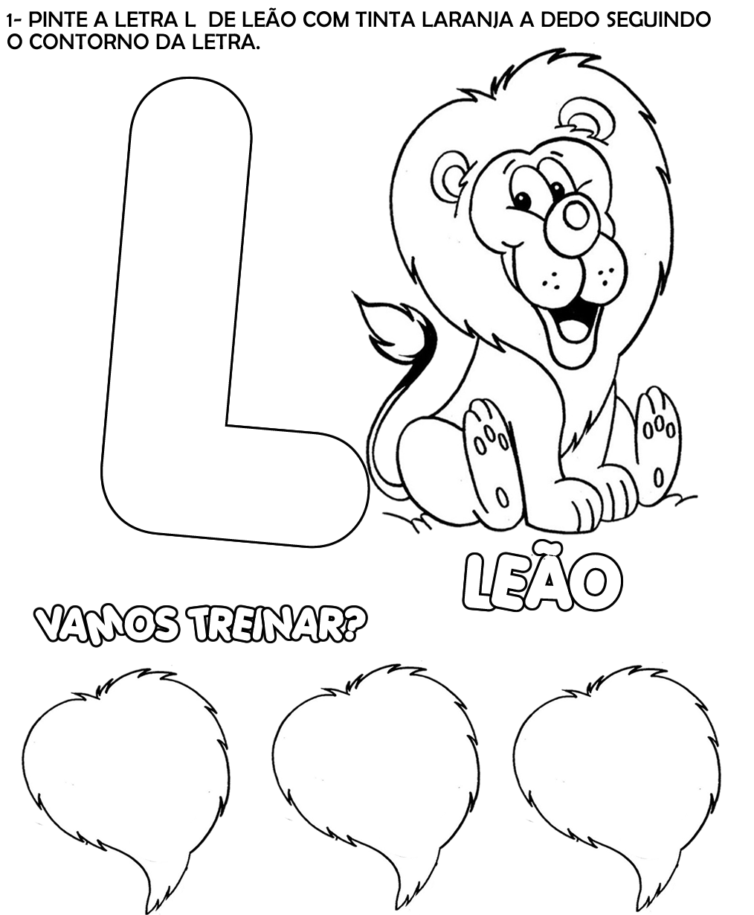



ALUNO (A): ________________________________________ DATA: 09 /09/ 2020.

PROFESSORA: _____________________________________

**MATERNAL II**

1 – AGORA VAMOS COLORIR O GRANDE RABANETE. EM SEGUIDA CIRCULE TODAS AS VOGAIS.

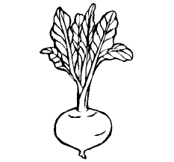

**RABANETE**