

ALUNO (A): ________________________________________ DATA: 09 /08/ 2020.

PROFESSORA: _____________________________________ MATERNAL I

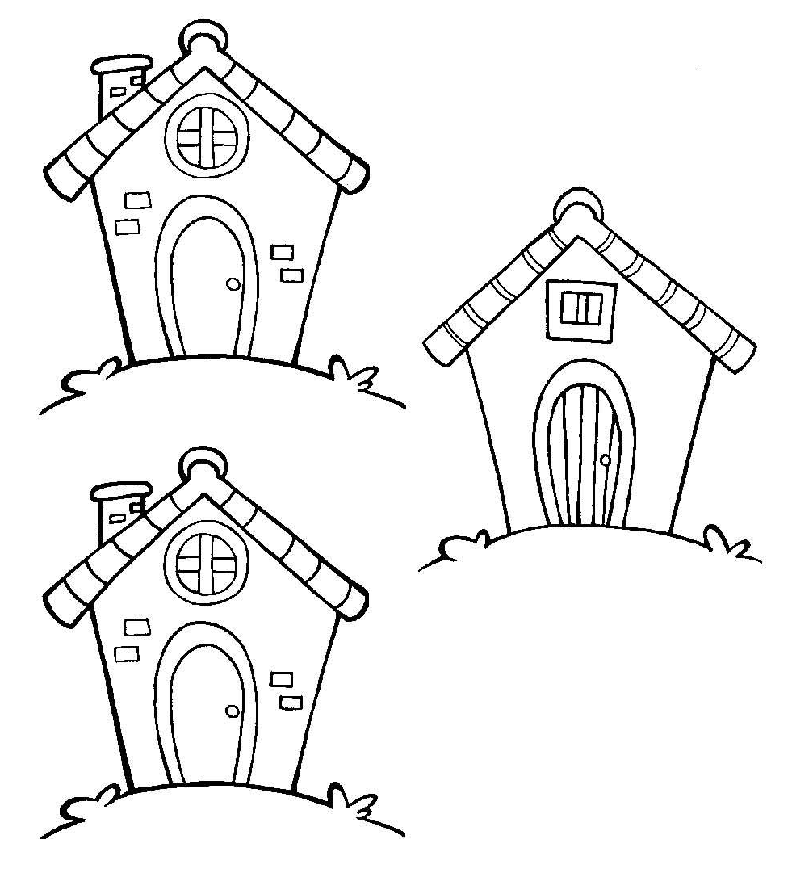PINTE AS CASAS **IGUAIS** E CIRCULE A **DIFERENTE.**