

ALUNO (A): ________________________________________ DATA: 09 /09/ 2020.

PROFESSORA: _____________________________________ MATERNAL I

Para casa 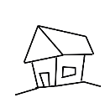

DOÇURA, LIGUE OS DESENHOS **IGUAIS**.

