

ALUNO (A): ________________________________________ DATA: 03/09/2020.

PROFESSORA: _____________________________________ **MATERNAL II**

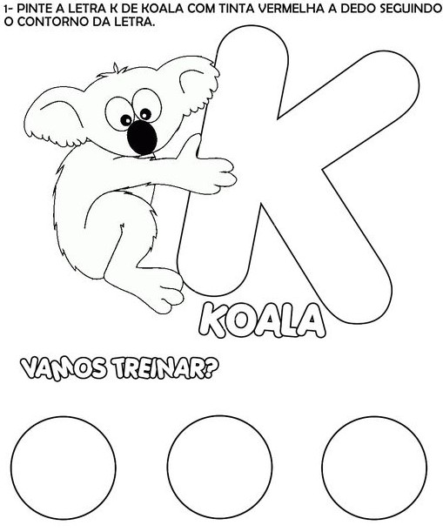



ALUNO (A): ____________________________________________ DATA: 03/09/2020

PROFESSORA: _______________________________________ **MATERNAL II**

