

ALUNO (A): ________________________________________ DATA: 02/09 2020.

PROFESSORA: _____________________________________ **MATERNAL II**

VAMOS PINTAR AS FRUTAS QUE TEM O NUMERAL 1.

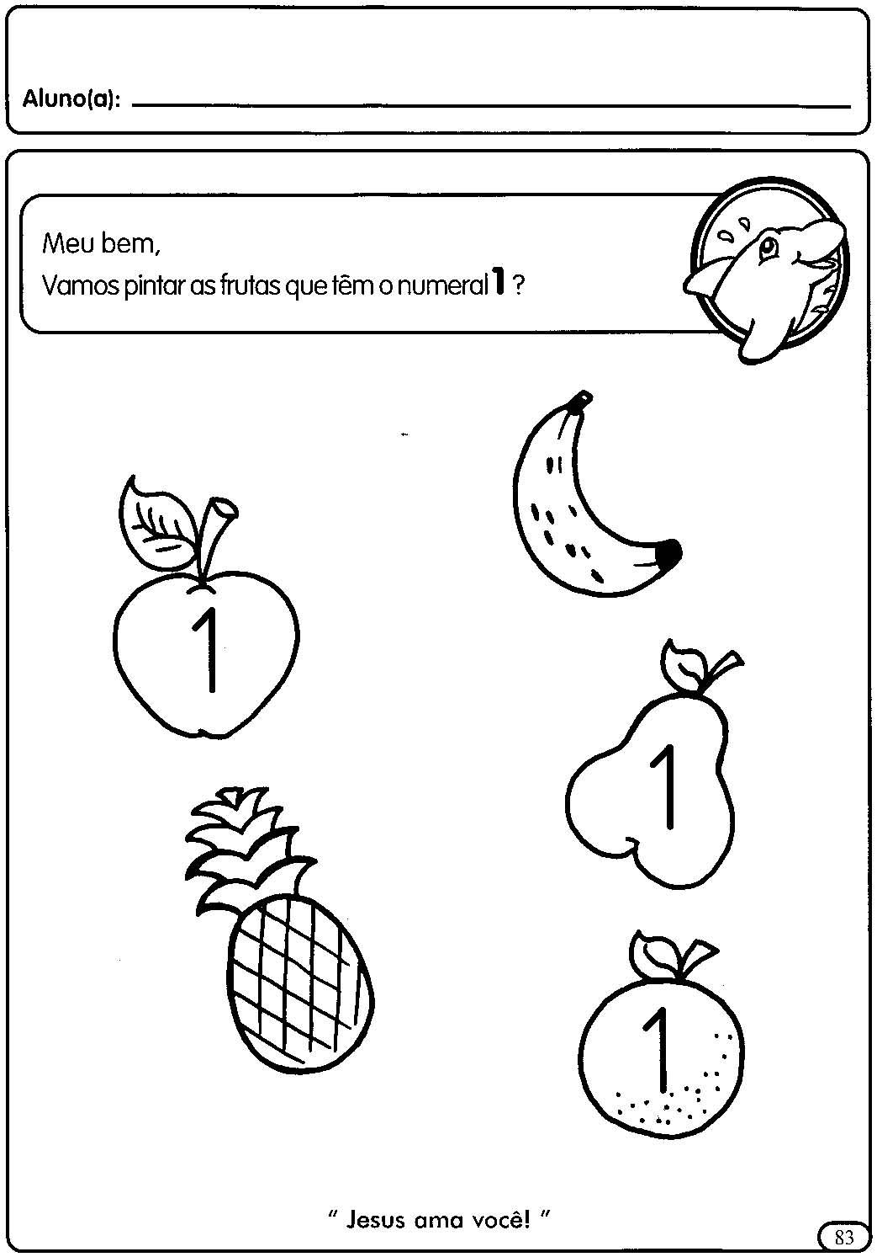



ALUNO (A): ________________________________________ DATA: 02 /09/ 2020.

PROFESSORA: ____________________________________________ **MATERNAL II**

LIGUE AS FRUTAS A SUA SILHUETA. DEPOIS PINTE AS FRUTAS

