

ALUNO (A): ________________________________________ DATA: 01/08/ 2020.

PROFESSORA: _____________________________________ **MATERNAL II**

LIGUE AS QUANTIDADES AOS NÚMEROS CORRESPONDENTES

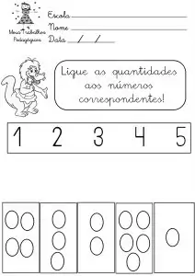



ALUNO (A): ________________________________________ DATA: 01/08/ 2020.

PROFESSORA: _____________________________________ **MATERNAL II**

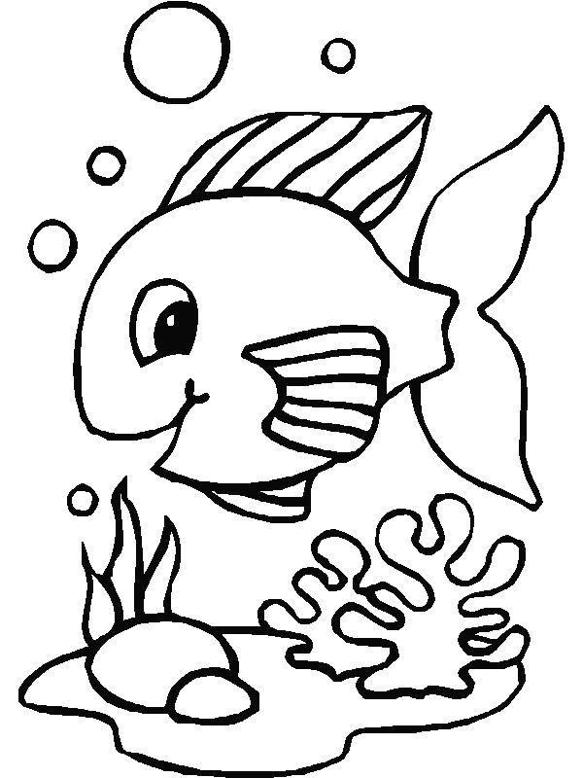Agora é a sua vez, vamos colorir o peixinho?