*Branca de neve e os sete anões*

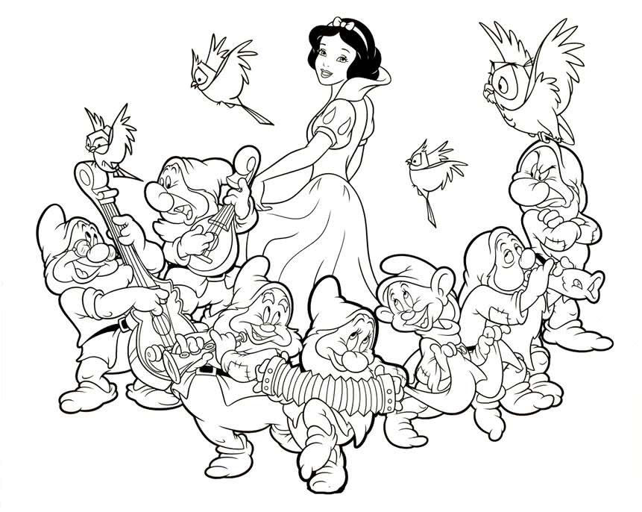



ALUNO (A): _______________________________________________ MATERNAL I