

ALUNO (A): ________________________________________ DATA: 14 /10/ 2020.

PROFESSORA: _____________________________________ MATERNAL I

**SEMANA DAS CRIANÇAS**

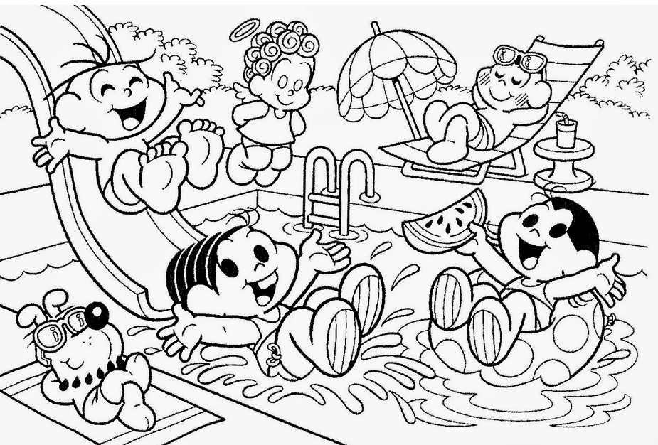



**FELIZ DIA DAS CRIANÇAS!**