

ALUNO (A): ________________________________________ DATA: 25 /08/ 2020.

PROFESSORA: _____________________________________ MATERNAL I

Para casa 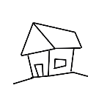

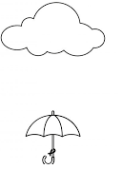FAÇA PINGOS DE CHUVA USANDO GIZ DE CERA.