

ALUNO (A): ________________________________________ DATA: 25 / 11 / 2020.

PROFESSORA: _____________________________________ MATERNAL I

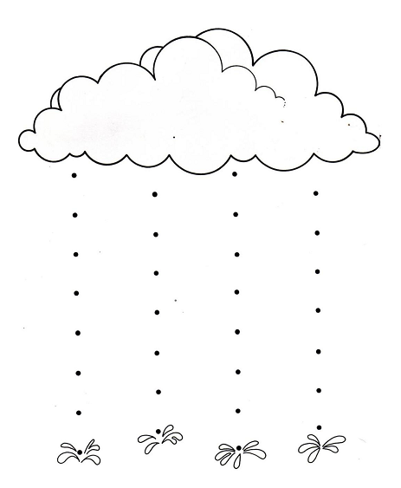COM TINTA GUACHÊ AZUL, FAÇA PINGOS DE CHUVA USANDO O DEDINHO.