

ALUNO (A): ________________________________________ DATA: 23 /11/ 2020.

PROFESSORA: _____________________________________ MATERNAL I

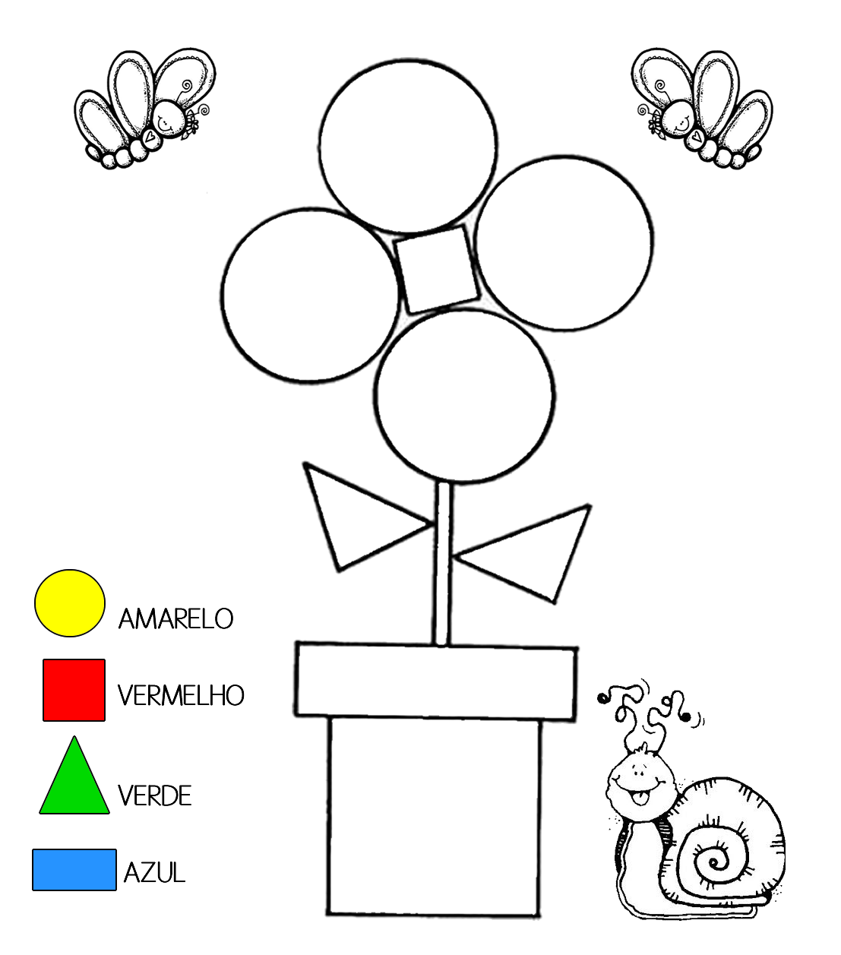PINTE A FLOR, SEGUINDO A LEGENDA DE CORES E FORMAS.