

ALUNO (A): ________________________________________ DATA: 24 /11/ 2020.

PROFESSORA: _____________________________________ MATERNAL I

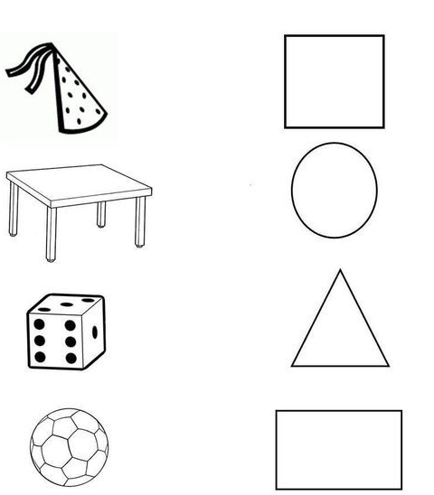LIGUE AS FIGURAS QUE TEM A MESMA FORMA :