ALUNO (A): ________________________________________ DATA: 11/11/ 2020.
PROFESSORA: ______________________________________________________
MATERNAL II

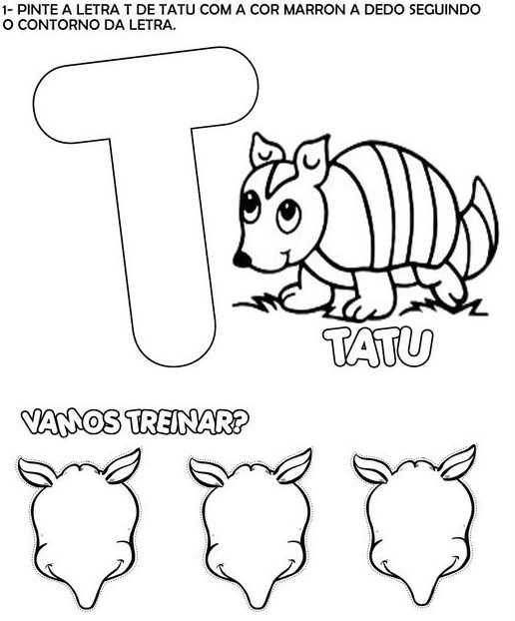

ALUNO (A): ________________________________________ DATA: 11/11/ 2020.
PROFESSORA: _____________________________________________________
MATERNAL II

