ALUNO (A): ________________________________________ DATA: 10 /11/ 2020.
PROFESSORA: _____________________________________
MATERNAL II
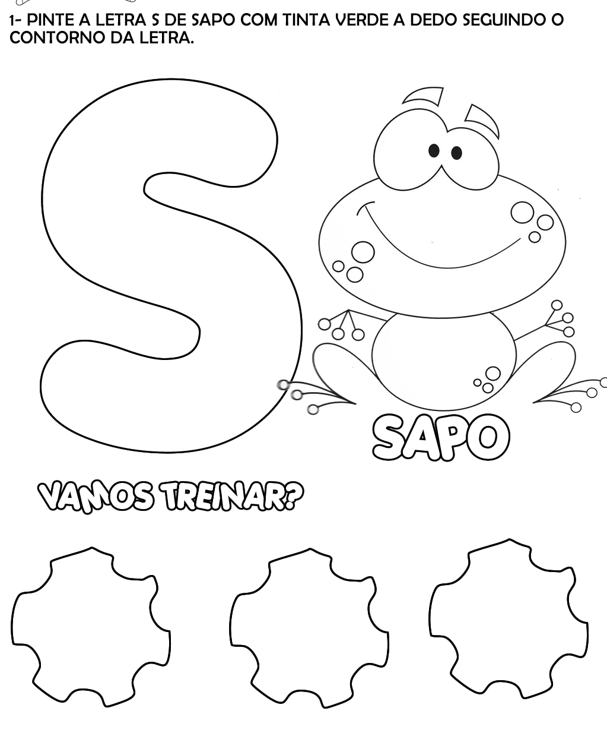

ALUNO (A): ________________________________________ DATA: 10 /11/ 2020.
PROFESSORA: _____________________________________
