

ALUNO (A): ________________________________________ DATA: 10 /11/ 2020.

PROFESSORA: _____________________________________ MATERNAL I

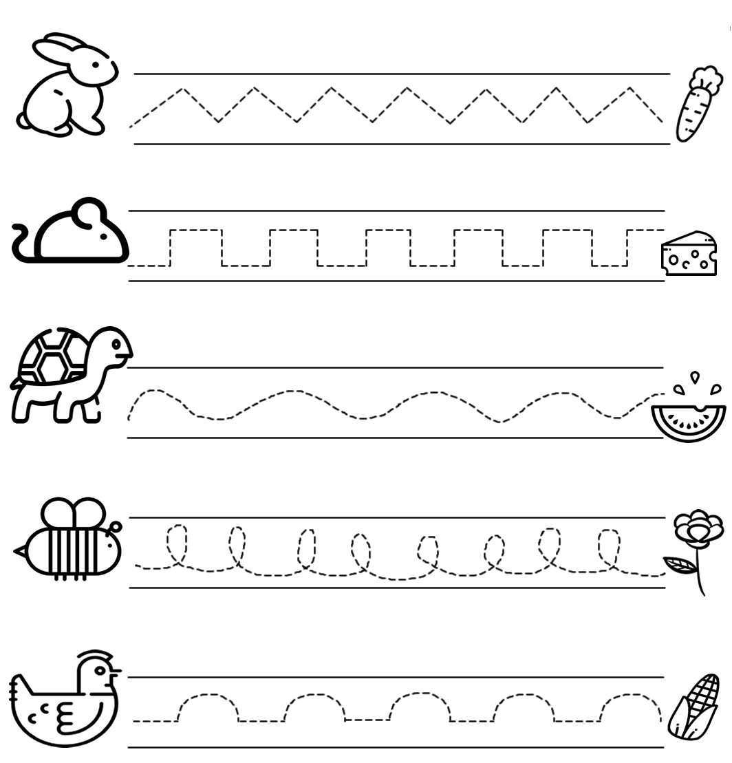**LEVE CADA ANIMAL AO SEU ALIMENTO, COBRINDO O CAMINHO.**