ALUNO (A): ________________________________________ DATA: 04/11/ 2020.
PROFESSORA: ______________________________________________________
MATERNAL II

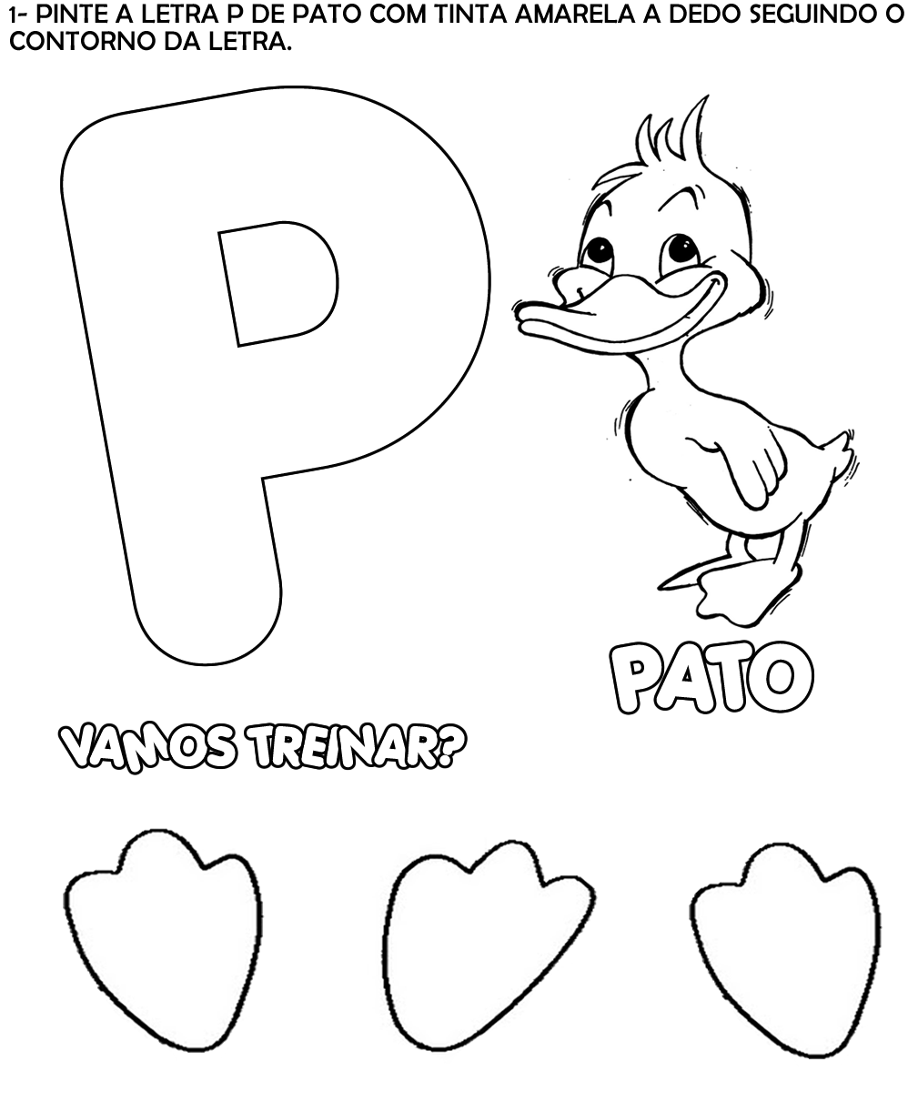
ALUNO (A): ________________________________________ DATA: 04/11/ 2020.
PROFESSORA: _____________________________________________________
MATERNAL II
